EXPT NO:2 | LOAD AND VISUALIZE A DATASET USING TABLEAU and PowerBI
DATE: 10.07.2026
Github link - https://github.com/j-abhishek26/24ADC001-24BAD002/tree/main/Experiment%202

PRE-LAB QUESTIONS (PROVIDE BRIEF ANSWERS TO THE FOLLOWING QUESTIONS)
- Why is Tableau a preferred tool for data visualization?
Tableau is favoured because it turns raw data into visuals purely through drag-and-drop — no scripting is required, so analysts can iterate quickly. It connects natively to a huge range of sources (Excel, SQL databases, cloud warehouses, web data connectors), its VizQL engine renders even large datasets with sub-second interactivity, and it ships with a wide library of chart types plus built-in geocoding for maps. Dashboards are highly interactive (filters, actions, tooltips) and publish easily to Tableau Server/Public/Cloud for sharing — which is why it is preferred by technical and non-technical users alike for exploratory and presentation-level analysis.
- What is the primary use of a line chart in data analysis?
A line chart's primary use is to show how a continuous measure changes over an ordered dimension — almost always time. It makes trends, growth or decline, seasonality, and turning points easy to spot at a glance, and plotting multiple lines lets you compare how several series (e.g., product categories) move relative to one another over the same period.

- When would you use a tree map instead of a bar chart?
A tree map is the better choice when the goal is to show hierarchical, part-to-whole relationships across many categories in a compact space — for example, Category drilling down into Sub-Category. It encodes proportion as nested rectangle area (and often colour), so it can display dozens of items without the axis clutter a bar chart would create. A bar chart remains better when precise value comparison or ranking between items is the priority, since length is easier to judge accurately than area.

- What is the significance of filters in Tableau visualizations?
Filters let users narrow a view down to a relevant subset of data — by date, region, category, or any other field — without altering the underlying dataset. They make dashboards interactive and reusable for different audiences (e.g., a regional manager filtering to just their own region), improve rendering performance by reducing the number of marks drawn, and, as quick filters or filter actions, can drive drill-down exploration across an entire dashboard from a single click.
- How does Tableau handle geographic data for visualizations?
Tableau automatically recognises common geographic field names (Country, State/Province, City, ZIP/Postal Code, Airport, etc.) and assigns them a “geographic role.” Behind the scenes it geocodes these values to latitude/longitude using its own built-in geocoding database, so a map can be built by simply double-clicking a geographic field. Users can layer symbol maps or filled choropleth maps, switch base layers (streets/terrain), and for locations Tableau does not recognise automatically, supply custom geocoding or plug in exact latitude/longitude coordinates.

IN-LAB EXERCISE:
OBJECTIVE:
To load a dataset into Tableau, create a variety of visualizations, and derive insights from the data using different chart types available in Tableau.

PROCEDURE:

Dataset Selection:
Use the Global Superstore Sales Dataset (available on Kaggle or Tableau's sample datasets).

Ensure the dataset includes fields like Order Date, Category, Region, Sales, Profit, and Customer Segment.

Data Loading:
Open Tableau and connect to the dataset.
Review the dataset structure, field data types, and missing values.
Chart Creations (Step-by-Step):
- Bar Chart:
Objective: Compare total sales by region and category.
Plot Region on the x-axis and Sales on the y-axis. Add Category as a color dimension.
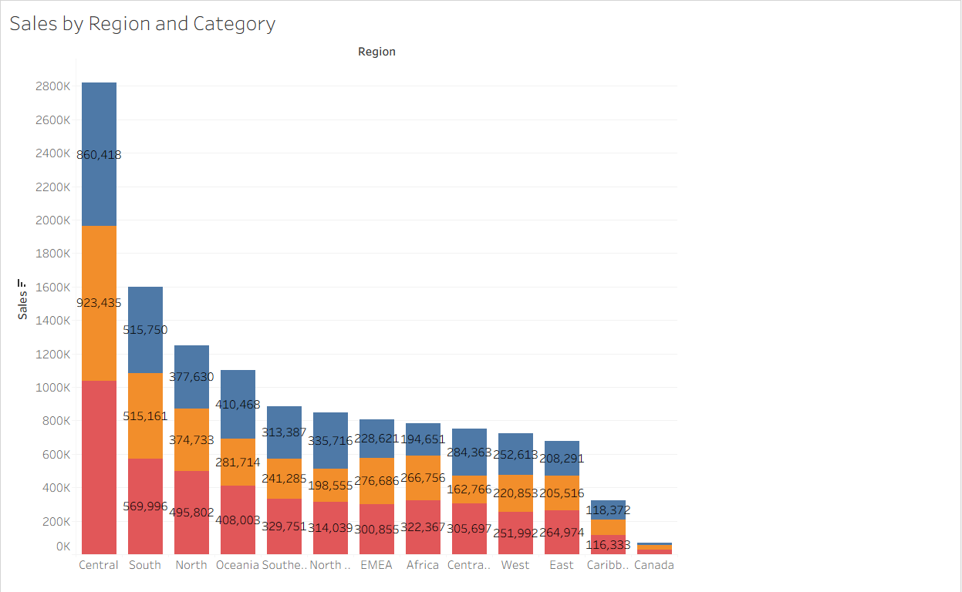

Line Chart:
Objective: Visualize sales trends over time.
Place Order Date on the x-axis and Sales on the y-axis. Set granularity to Month and color by Category.
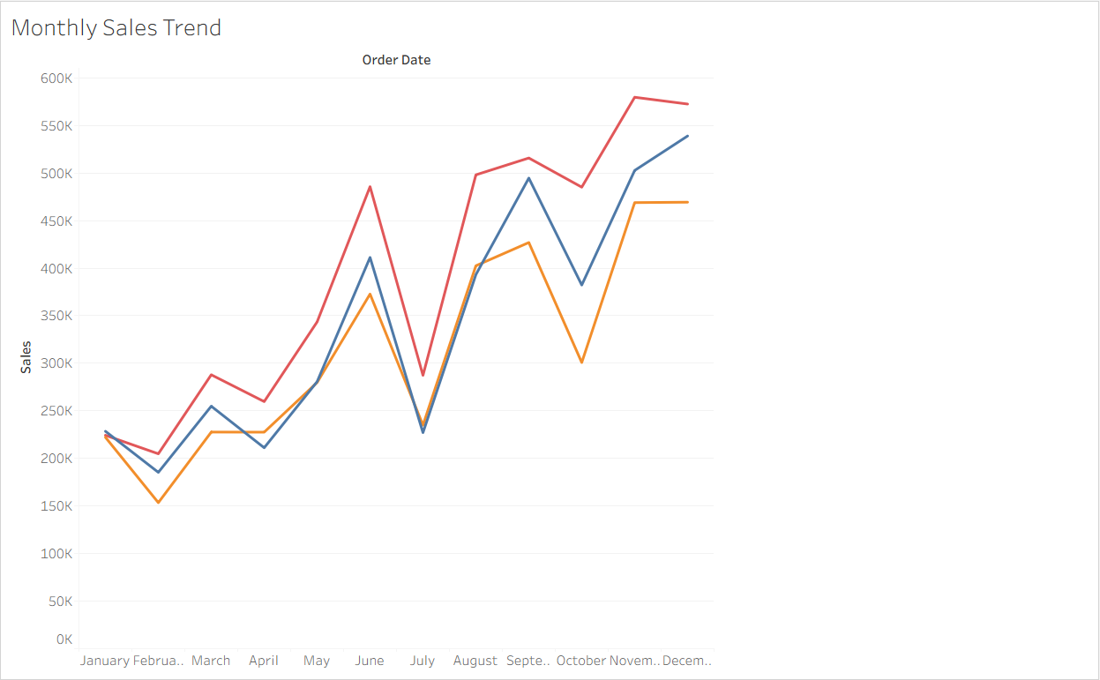

Pie Chart:
Objective: Show sales distribution by product category.
Assign Category as the dimension and Sales as the measure.

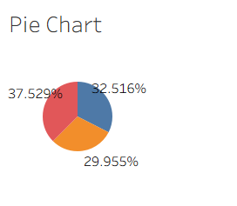

Scatter Plot:
Objective: Examine the relationship between profit and sales.
Plot Profit on the x-axis and Sales on the y-axis.
Use Sub-Category as the color dimension.
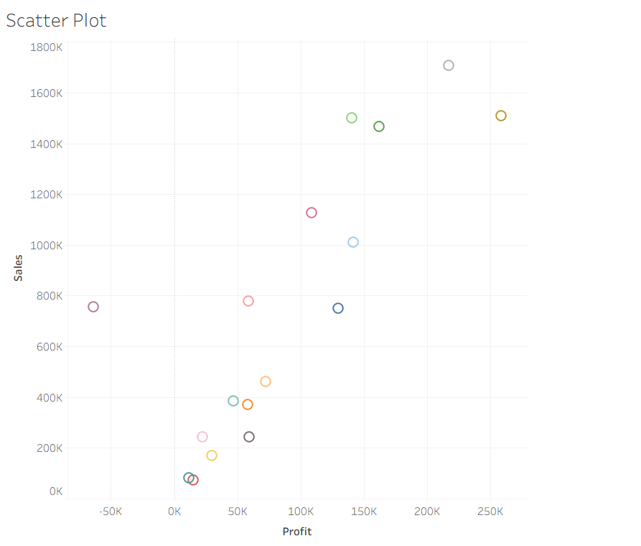

Heatmap:
Objective: Compare sales across categories and regions.
Use Region and Category as dimensions.
Use Sales as the measure and apply color coding.
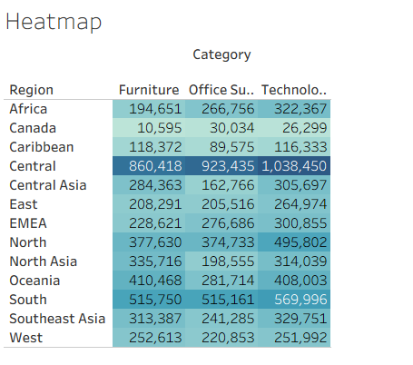

Geographical Map:
Objective: Visualize total sales by country.

Set Country as the geographical field.
Use Sales to define size and color gradients.
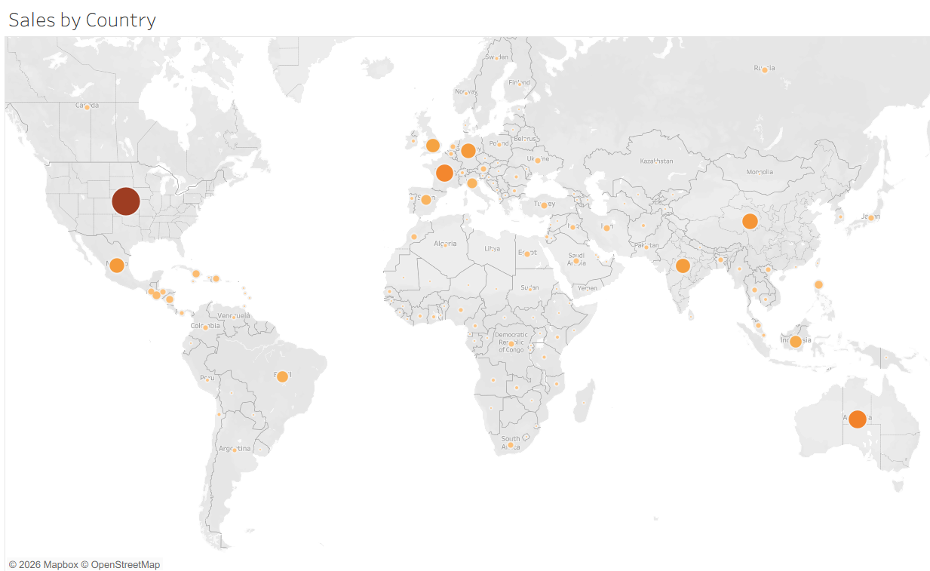

Tree Map:
Objective: Display sales distribution by category and sub-category. Use Category and Sub-Category as dimensions, and Sales as the measure.
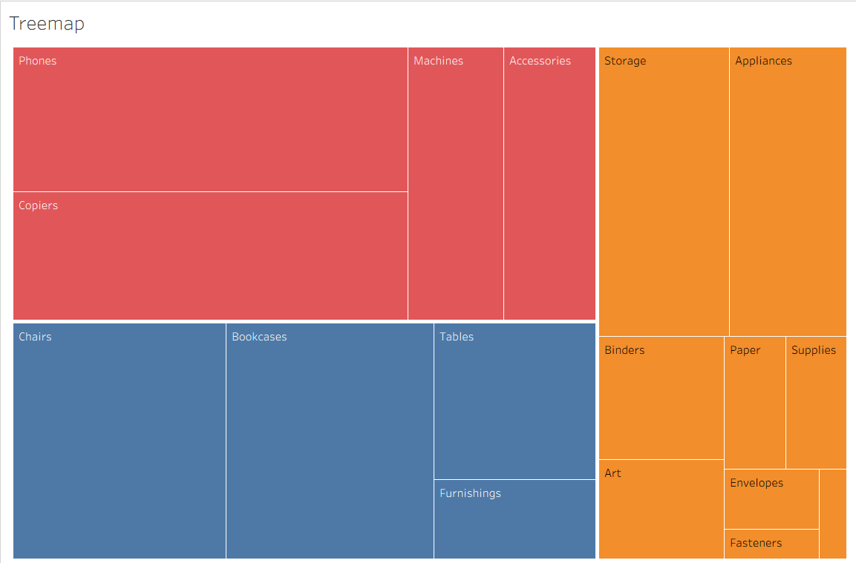
Customization and Interactivity:
Add filters to explore data subsets interactively (e.g., by year, region, or category). Include annotations, labels, and formatting for clarity.

Dashboard Creation:
Combine all charts into a single dashboard to present a cohesive story. Add interactive filters and tooltips for dynamic exploration.

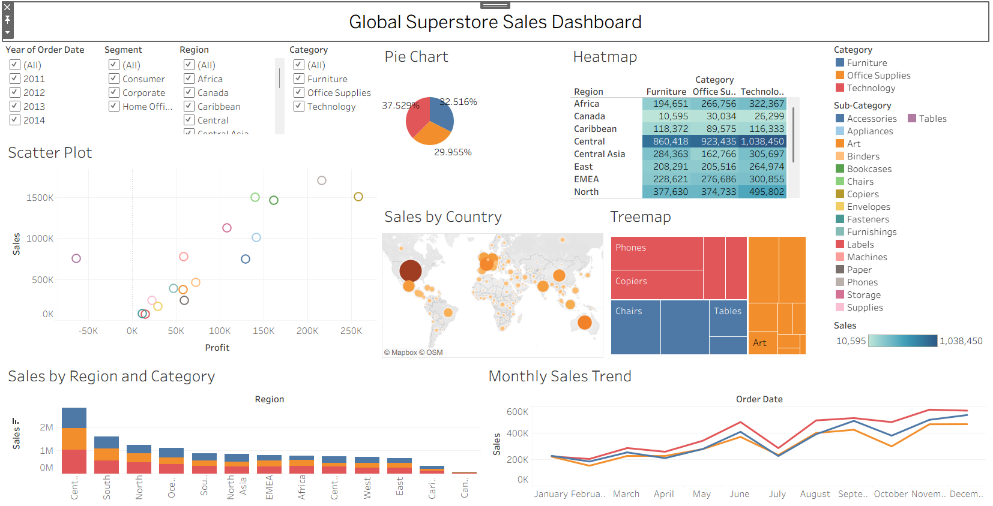
POWERBI DASHBOARD:
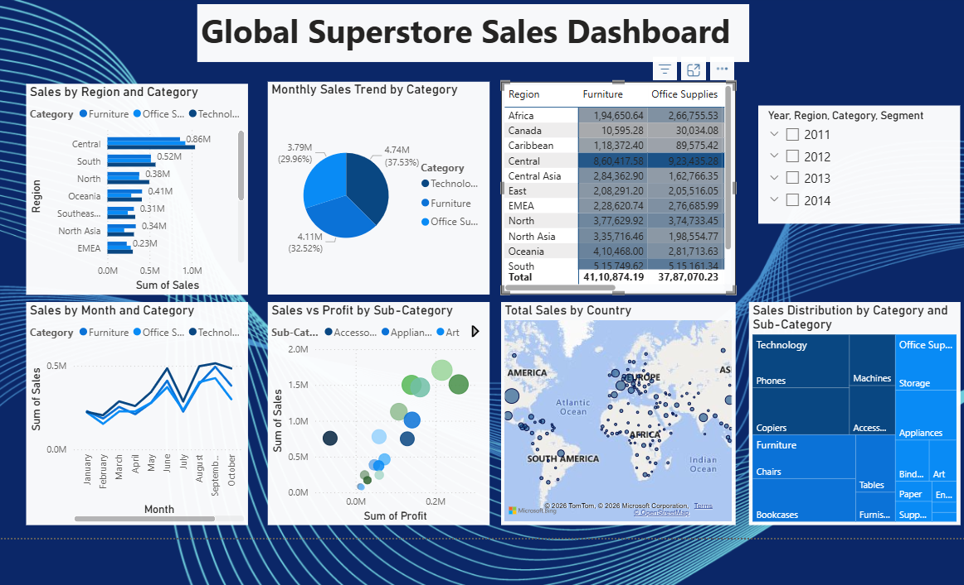

Experiment Dataset:
Global Superstore Sales Dataset
Source: https://www.kaggle.com/datasets/apoorvaappz/global-super-store-dataset

Fields Used:
Order Date Region Category
Sub-Category Sales
Profit

Country

POST-LAB QUESTIONS (PROVIDE BRIEF ANSWERS TO THE FOLLOWING QUESTIONS)

Bar Chart:
What regions had the highest and lowest total sales?
The Central region recorded the highest total sales with 2,822,302.52, while the Canada region recorded the lowest total sales with 66,928.17.

How does the performance of categories vary across regions?
The Central region performed the best across all categories:
- Technology: 1,038,449.66
- Office Supplies: 923,435.28
- Furniture: 860,417.58
The Canada region showed the lowest overall sales across all categories.

Line Chart:
Identify the month with peak sales.
The month with the highest total sales is December, with total sales of 1,580,780.77.
Which category shows consistent growth in sales over time?
Office Supplies shows the most consistent sales growth over time, with relatively stable monthly performance compared to the other categories.

Pie Chart:
Which category contributes the most to overall sales?
Technology contributes the highest share of total sales with 4,744,557.50.
Are there any categories with negligible sales contributions?
No. All three categories contribute significantly to the overall sales. However, Office Supplies has the lowest contribution (3,787,070.23) among the three categories.

Scatter Plot:
Is there a noticeable correlation between profit and sales?
Yes. The correlation coefficient between Sales and Profit is 0.485, indicating a moderate positive correlation. This means that, in general, products with higher sales tend to generate higher profits, although there are notable exceptions.
Which sub-category shows the highest sales but low profit?
The Tables sub-category has high sales but low profitability.
- Total Sales: 757,041.92
- Total Profit: −64,083.39
This indicates that despite generating substantial sales, Tables resulted in an overall loss.

Heatmap:
Which region-category combination has the highest sales?
The Central – Technology combination recorded the highest sales.
- Region: Central
- Category: Technology
- Total Sales: 1,038,449.66

Identify any regions with poor sales performance across all categories.
The Canada region had the poorest overall sales performance, with total sales of 66,928.17, making it the lowest-performing region in the dataset.

Geographical Map:
Which country has the highest total sales?
The United States generated the highest total sales.
- Country: United States
- Total Sales: 2,297,200.86
Are there regions with minimal or no sales?
There are no regions with zero sales. However, the Canada region has the minimum sales, with a total of 66,928.17.
Tree Map:
Which sub-category dominates the sales in each category? Are there any sub-categories with unexpectedly low sales?
Category | Highest Selling Sub-Category | Total Sales
Furniture | Chairs | 1,501,681.76
Office Supplies | Storage | 1,127,086.39
Technology | Phones | 1,706,824.14

Yes. The lowest-selling sub-categories are:
Sub-Category | Total Sales
Labels | 73,404.03
Fasteners | 83,242.32
Envelopes | 170,904.30
These sub-categories contribute relatively little to the overall sales.

Dashboard:
What insights can you derive when combining all visualizations?
The dashboard reveals that the Technology category is the top performer with 4,744,557.50 in sales. The Central region generates the highest regional sales (2,822,302.52), while the United States is the leading country with 2,297,200.86 in sales. December is the highest-selling month (1,580,780.77). Although the Tables sub-category records high sales (757,041.92), it incurs an overall loss of −64,083.39, indicating low profitability despite strong revenue.
How do filters enhance the utility of the dashboard?
Filters allow users to interactively analyze data by Year, Region, Category, Segment, and Country, making it easier to compare sales trends, identify top-performing products and regions, and gain focused business insights without modifying the underlying dataset.

ASSESSMENT

Description | Max Marks | Marks Awarded
Pre Lab Exercise | 5
In Lab Exercise | 10
Post Lab Exercise | 5
Viva | 10
Total | 30
Faculty Signature

